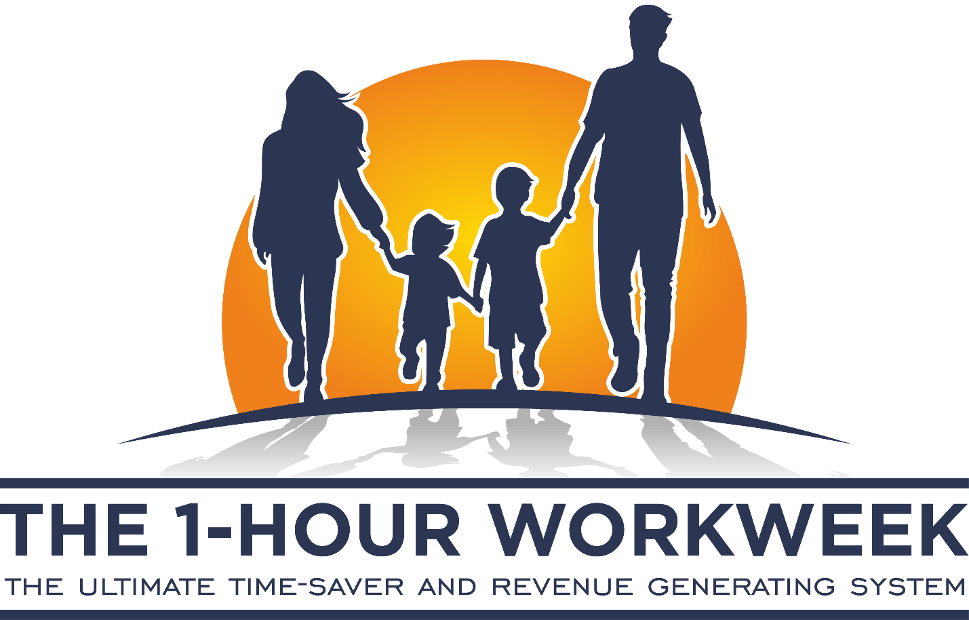

Hello Facebook Friends,

Come & Join Our Movement: We believe that every person has the right to enjoy happiness, good health, time-freedom and financial-freedom…regardless of who they are, where they live, and what they do.

You can acquire our 4 Pillars of Success:

https://www.the1hourworkweek.com/pillars-of-success/

To join our movement…if you purchase just $25 in retails products, you get a lifetime FREE membership.

For such a small investment on products you use every day, this is an amazing opportunity with a minimum “one-time” order and the option to order products monthly…while getting paid cash rewards and cash back rebates.

Bonuses include:

* Top Sponsor Bonus Incentives
* FREE iPhone 8
* Star Recognition Bonus
* $500+ Shopping Spree Bonus
* Yearly Performance Bonus

On top of this…you get paid 30% cash-back income on the initial purchases of all the Facebook friends you refer.

Plus…

You get paid 5% cash-back on the next 100,000 Facebook followers who join after you.

In other words…

They pay you $1+ on each of the next 100,000 Facebook subscribers who join their shopping network for a total income of $100,000.

Yep! That’s right. This is monthly income which is “mad crazy” money.

And here’s the kicker….

All you have to do is share this same message on your Facebook page as your leisure. That’s all. Nothing more.

So how easy is this when you’re on Facebook all the time anyway?

In addition…

The first 1,000 Facebook subscribers who sign-up will qualify to win a brand new iPhone 8. So you better get signed-up fast.

Finally…

On April 24th, 2019…here’s what going to happen: They are giving away $500 in FREE products.

If you both “Like” our page & “Follow-us” on Facebook…you could win $100 in FREE products from our shopping network. Presently…we have a quality selection of more than 80,000 products.

If you “post” the “best” comment on our Facebook page…you could win $100 in FREE products.

https://www.facebook.com/the1hourworkweek

If you “register” for our FREE membership program before this deadline…you could win $200 in FREE products.

Listen! You gonna spend the money anyway. So why not set-up yourself so that you can acquire our 4 Pillars of Success:

https://www.the1hourworkweek.com/pillars-of-success/

On midnight of April 24th, they will announce the winners on their official Facebook page. The winners will receive a private Facebook message on “how to claim” their prizes.

With that being said…

Click the link below and go on over to The 1 Hour Workweek and watch a 60-second video [if not attached to this message already] and get all of the detail.

And take a few seconds to download this simple message and start sharing. Man I’m loving it…

https://www.the1hourworkweek.com/promotions/?ref=YOUR
USERNAME HERE

