Monthly Cash Bonuses & Cash-Back Plans Program

Participate in our monthly contest and win 5 cash bonuses and get paid on two wealth generating cash-back plans.

Bonus #1: Top Referral Bonus Program
You could win $1,000, $500 or $300 in “cold” hard cash money with our monthly “new member” referral program. This money is deposited directly into your PayPal account at the end of the month.

*You will win $1,000.00 cash bonus if you sponsor the highest number of new members for the month. You require a minimum of 30 or more new member sign-ups to qualify.

*You will win $500.00 cash bonus if you sponsor the second highest number of new members for the month. You require a minimum of 15 or more new member sign-ups to qualify.
*You will win $300.00 cash bonus if you sponsor the third highest number of new members for the month. You require a minimum of 10 or more new member sign-ups to qualify.

Bonus #2: iPhone Giveaway
Your name will be entered into a drawing to win a brand new iPhone 8 after 1,000 Facebook subscribers have registered.

Bonus #3: Star Recognition Bonus
If you become the top sponsor for the month, you will be featured on our website for the entire year. That’s right! You get the join “The Wall of Stars” where we profile you as a “rising star” in the eyes of all our members and 1,000’s of visitors to our website.

Bonus #4: $500 Shopping Spree Bonus
If you are the first place winner, you can choose $350 in free retail products from The 1 Hour Workweek selection of 1,000’s of quality retail products.

If you are the second place winner, you can choose $150 in free retail products from The 1 Hour Workweek selection of 1,000’s of quality retail products.

We encourage all participants to visit the site to shop for the products they like well before the end of the month. In the near future, we plan to upload nearly 150,000 quality products.

See our Products: https://www.the1hourworkweek.com/shop/

Bonus #5: Yearly Performance Bonus
If you are the first place winner with the most number of new member for the entire year, you will receive a cash-bonus of $2,500 on December 31th.

You will require average of 30 or more customers over a 12 month period. This year will be prorated since the contest begin in March of this year.

If you are the second place winner with the second most number of new member for the entire year, you will receive a cash-bonus of $1,000 on December 31th.

You will require average of 20 or more customers over a 12 month period. This year will be prorated since the contest begin in March of this year.

The more financial success we have this year as a company, it’s very likely that all of our cash bonus values will be increasing across the board over the course of this year.

Cash Back Incentive #1: Direct Referral Cash Back
You get paid 30% cash-back income on the initial purchase of all the people you refer that join our shopping network. This cash-back incentive is based on our Bonus #1: Top Referral Bonus Program. This is based on an average sale from $25 - $50. There is no limit to the number of people you can personally sponsor.

*10 new members = $75 - $150
*15 new members = $113 - $225
*30 new members = $225 - $450
*40 new members = $300 - $600
*50 new members = $375 - $750
*60 new members = $450 - $900
*70 new members = $525 - $1,050
*80 new members = $600 - $1,200
*90 new members = $675 - $1,350
*100 new members = $750 - $1,500
*500 new members = $3,750 - $7,500
*1000 new members = $7,500 - $15,000

Cash Back Incentive #2: Indirect Referral Cash Back
This is our most lucrative program where you get paid unlimited monthly cash-back residual income. In this program, you get paid 5% cash-back on the next 100,000 Facebook and all other subscribers who follow you regardless of who referred them. This program is intended for long-term growth to achieve our 4 Pillars of Success: Happiness, Better Health, Time-Freedom & Financial-Freedom.

*1,000 members = $1,250 - $2,500
*5,000 members = $6,250 - $12,500
*10,000 members = $12,500 - $25,000
*20,000 members = $25,000 - $50,000
*30,000 members = $37,500 – 75,000
*40,000 members = $50,000 - $100,000
*50,000 members = $62,500 - $125,000
*60,000 members = $75,000- $150,000
*70,000 members = $87,500- $175,000
*80,000 members = $100,000 - $200,000
*90,000 members = $112,500 - $125,000
*100,000 members = $125,000 - $150,000

If you’re interested in becoming a member with The 1 Hour Workweek and getting paid easy cash from our 5 cash bonus programs and our 2 cash-back incentive programs…register for your FREE membership today!

Note: 1 membership = 20,000 affiliate partners. We allow up to 5 memberships at the present time. Each membership require a separate email account. So if you have a small group of followers, perhaps you should start with 1 membership account (e.g. affiliate link). However, if you have 100,000 followers, you may consider rotating up to 5 membership accounts to your followers.

Home Page Design

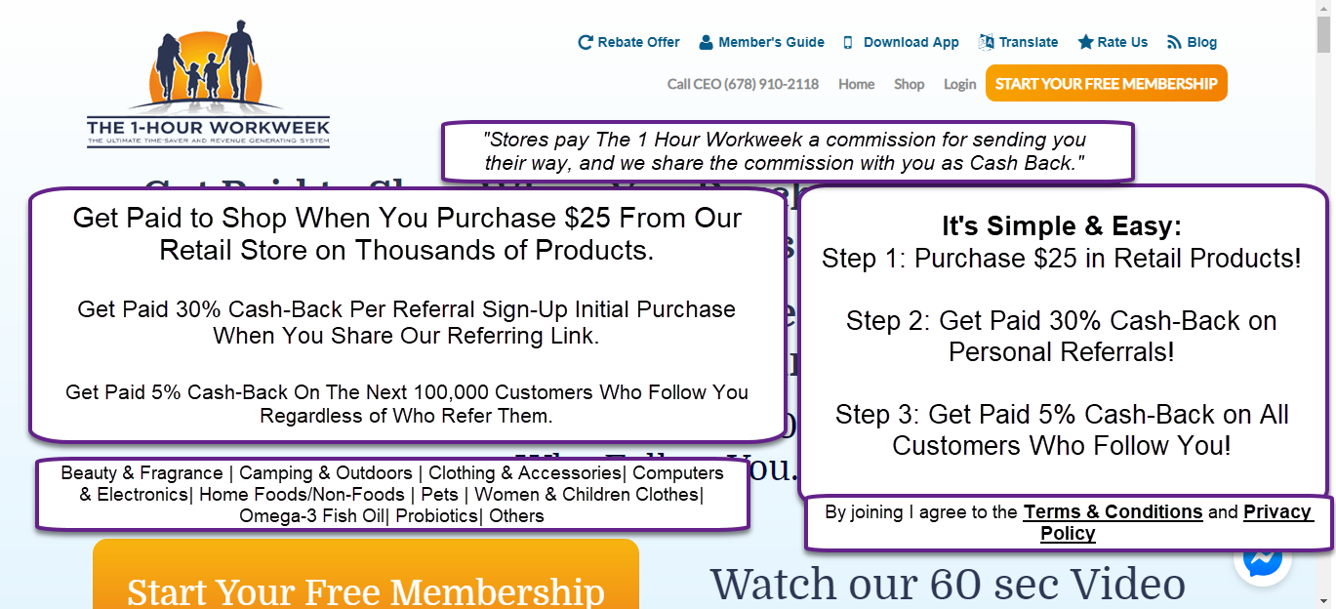
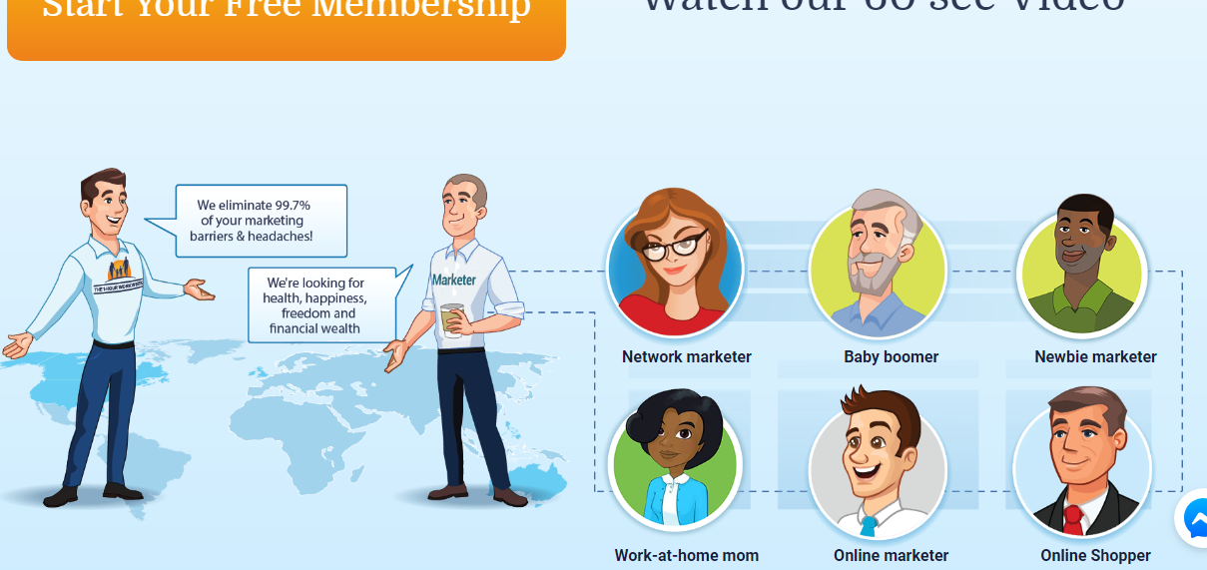
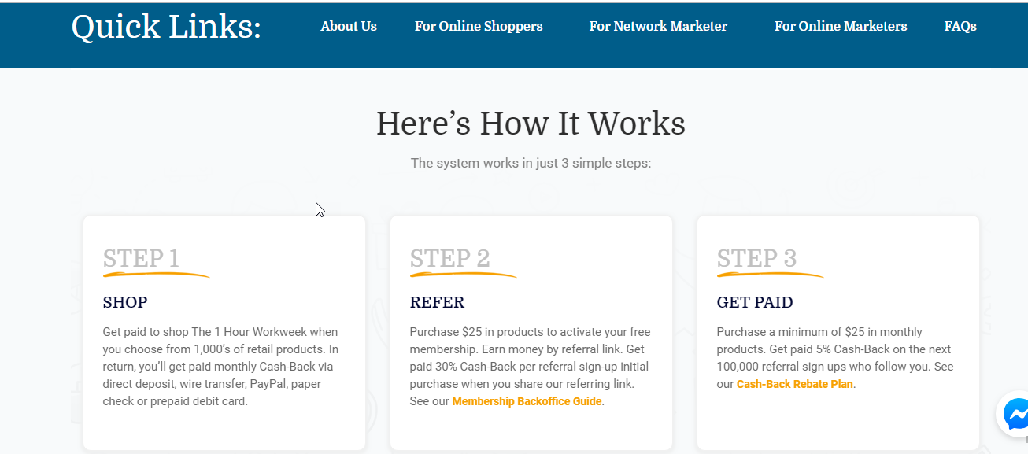

Monthly Cash Bonuses & Cash-Back Plans Program
[Note: the headline above will link to the page Karen is creating]
Participate in our monthly contest and win a total of 5 different cash bonuses and 2 wealth generating cash-back plans:

Bonus #1: Top Referral Bonus Program
You could win $300, $150 or $100 in “cold” hard cash money…
For More Details…

Bonus #2: iPhone Giveaway
Your name will be entered into a drawing to win a brand new iPhone 8 after 1,000 affiliate members have registered.
For More Details…

Bonus #3: Star Recognition Bonus
This bonus is where the top sponsor for the month is featured…
For More Details…

Bonus #4: $450 Shopping Spree Bonus
This bonus is given to the top two sponsors for the month.
For More Details…

Bonus #5: Yearly Performance Bonus
This bonus is given to the 2 top sponsors for the year.
For More Details…

Cash Back Incentive #1: Direct Referral Cash Back
You get paid 30% cash-back income on the initial purchase of all the people you refer that join our shopping network. This cash-back…
For More Details…

Cash Back Incentive #2: Indirect Referral Cash Back
This is our most lucrative program where you get paid unlimited monthly cash-back residual income. In this program, you get paid 5…
For More Details…

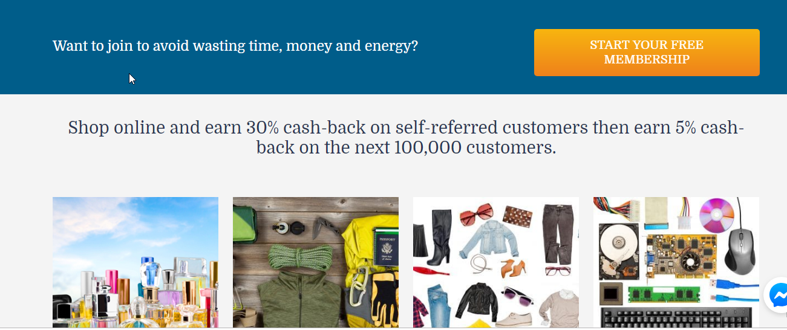

Continue the rest of the site as is.

Can you design the site so that on the home page you can show only a short description as in Diagram A? Then when you click on “For More” the page will open up to show the full content in Diagram B?

Diagram A

Bonus #1: Top Referral Bonus Program
You could win $300, $150 or $100 in “cold” hard cash money… For More Details…

Diagram B
Bonus #1: Top Referral Bonus Program
You could win $300, $150 or $100 in “cold” hard cash money with our monthly “new member” referral program deposited directly into your PayPal account.

*A $300.00 cash bonus is given to the #1 member who sponsors the most number of new members for the month. They require a minimum of 30 or more new member sign-ups to qualify.

*A $150.00 cash bonus is given to the #2 member who sponsors the second most number of new members for the month. They require a minimum of 15 or more new member sign-ups to qualify.

*A $100.00 cash bonus is given to #3 member who sponsors the third most number of new members for the month. They require a minimum of 10 new member sign-ups to qualify.

